SMAI REPORT :2023121006­­­­­­­­

The figures folder has been moved into the assignment-specific directory. You should save all the generated plots, animations, etc inside that folder and then include them in the report.

Run : python -m assignments.1.a1 --data_sample {is_integer_total_data_rows_for_knn}

KNN

Task_2_2_1()

­­

Distribution :

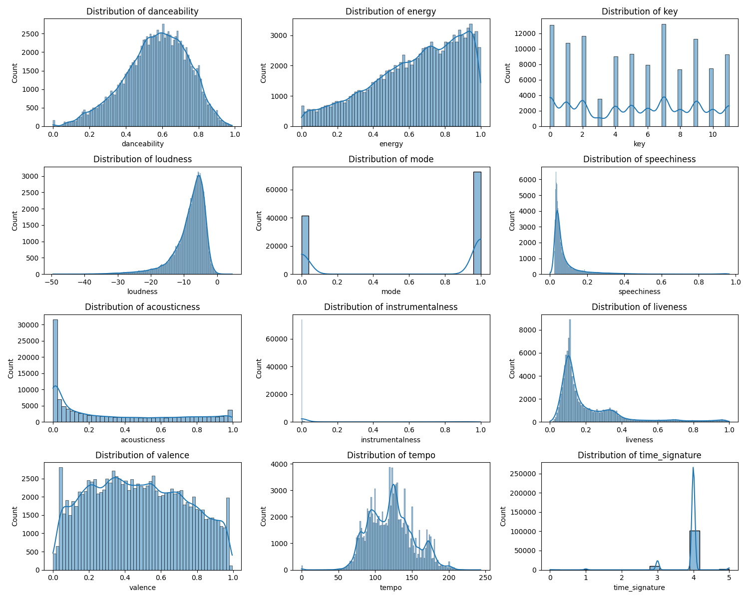

Observation: time_signature, mode are not distribted. Hence we wont be able to put vector completely on basis of such feature.

These features don't vary much across your dataset, they might not contribute significantly to the KNN model's ability to differentiate between genres.

Acousticness, danceability,valence, energy should be most relevant for genre classification as they are more widespread in space.

Because they capture more nuanced characteristics of the audio, they are likely to be more useful for genre classification

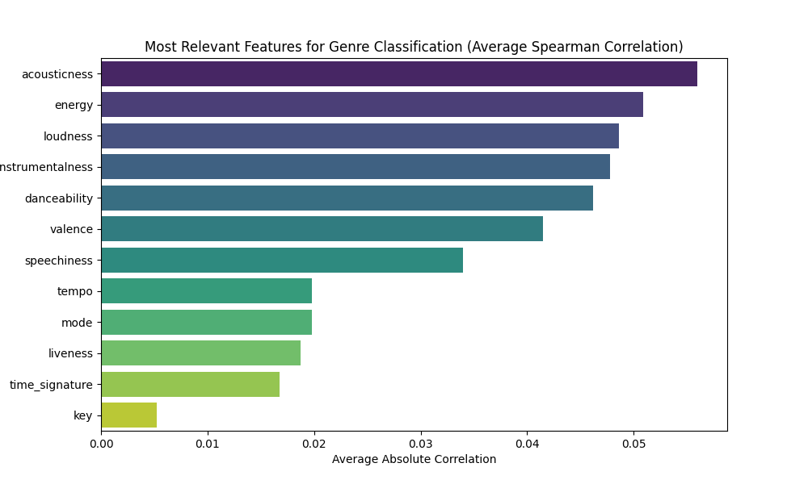

Plot of order/hierarchy according to most relevant features using spearman correlation

Task :2_3_1 done in models/knn/knn.py and performance_measures/performance.py took care

Note :

Used concurrent.futures to paralleize multiple possibilities for {k,distance_metric} ,finding best pair.

Parallelism not used/done in knn.py

Uncomment : task3_1_3()

1. Find the best {k, distance metric} pair that gives the best validation accuracy for an 80:10:10 split (train:test:validation).

Ans: I permuted dis_metric=['euclidean','manhattan','cosine','hamming'] and pred_type= [ 'most_common','weighted_sum'] ,k=[1,3,5,7,9,11,13,15,17,19] . Took ‘hamming’ and ‘weighted_sum’ as extra to experiment with

2. Print an ordered rank list of the top 10 such pairs.

Top 10 Accuracy Pairs:

k: 15, Distance Metric: Manhattan, Prediction Type: Weighted Sum, Accuracy: 0.985706

k: 17, Distance Metric: Manhattan, Prediction Type: Weighted Sum, Accuracy: 0.985702

k: 19, Distance Metric: Manhattan, Prediction Type: Weighted Sum, Accuracy: 0.985676

k: 13, Distance Metric: Manhattan, Prediction Type: Weighted Sum, Accuracy: 0.985645

k: 11, Distance Metric: Manhattan, Prediction Type: Weighted Sum, Accuracy: 0.985639

k: 9, Distance Metric: Manhattan, Prediction Type: Weighted Sum, Accuracy: 0.985594

k: 7, Distance Metric: Manhattan, Prediction Type: Weighted Sum, Accuracy: 0.985565

k: 5, Distance Metric: Manhattan, Prediction Type: Weighted Sum, Accuracy: 0.985532

k: 19, Distance Metric: Euclidean, Prediction Type: Weighted Sum, Accuracy: 0.985491

k: 1, Distance Metric: Manhattan, Prediction Type: Weighted Sum, Accuracy: 0.985489

3. Plot k vs accuracy given a choice (yours) of any given {k, distance metric} pair with a constant data split. (on full data):

heatmap to represent best way: for most_common and weighted_sum

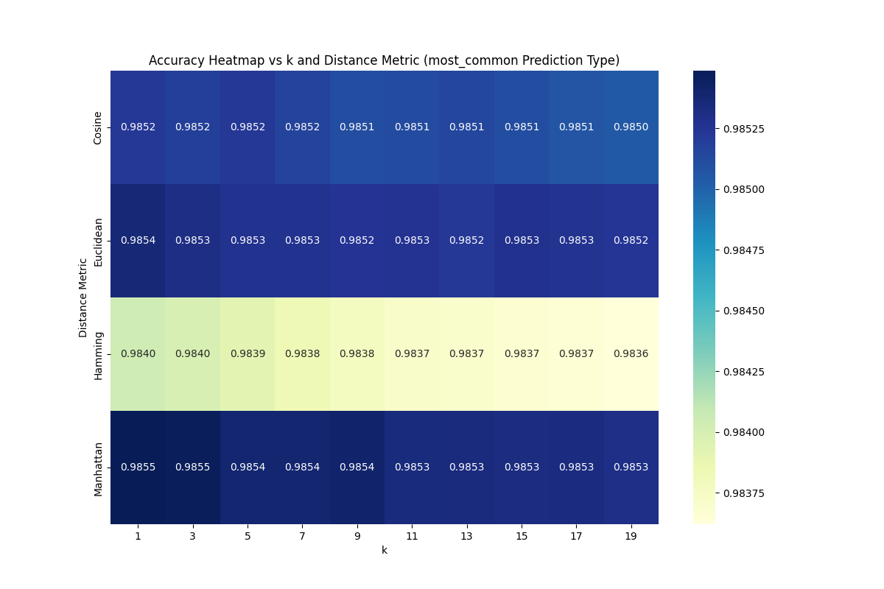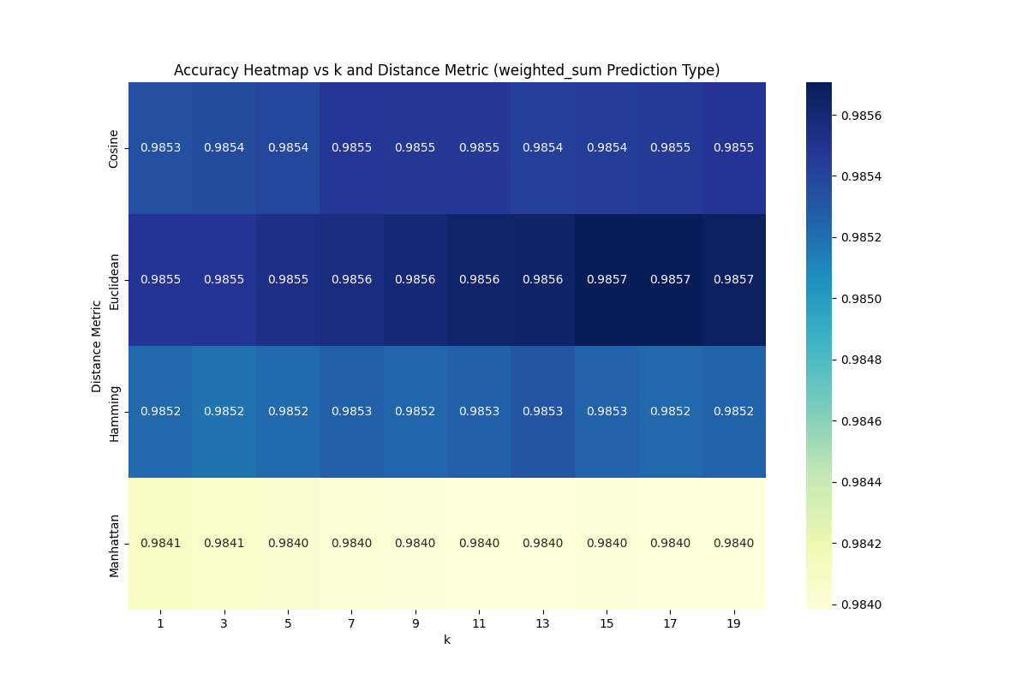

task3_4_5()

4. More data need not necessarily mean best results. Try dropping various columns and check if you get better accuracy. Document the combination with which you get the best results.

WITH :k: 15, Distance Metric: Manhattan, Prediction Type: Weighted Sum

Top 5 results:

 features ('danceability', 'energy', 'loudness', 'speechiness', 'acousticness', 'instrumentalness', 'valence', 'tempo') , accuracy 0.9858387196060326

 features ('danceability', 'energy', 'loudness', 'mode', 'speechiness', 'acousticness', 'instrumentalness', 'liveness', 'valence', 'tempo', 'time_signature') , accuracy 0.9858156355801785

 features ('danceability', 'energy', 'loudness', 'mode', 'speechiness', 'acousticness', 'instrumentalness', 'valence', 'tempo') , accuracy 0.9857602339181286

 features ('danceability', 'energy', 'key', 'loudness', 'mode', 'speechiness', 'acousticness', 'instrumentalness', 'liveness', 'valence', 'tempo', 'time_signature') , accuracy 0.98567405355494

 features ('danceability', 'energy', 'loudness', 'speechiness', 'acousticness', 'instrumentalness', 'valence') , accuracy 0.9855263157894737

5. [Bonus] Try for all combinations of columns and see which combination gives the best result. See if that matches with the analysis made during data exploration.

This combination :('danceability', 'energy', 'loudness', 'speechiness', 'acousticness', 'instrumentalness', 'valence', 'tempo')

Yes , it matches with the analysis made during data exploration.

Since , all top features in hierarchy result is obtained

2.5 Optimization

1. Improve the execution time of the program using vectorization.

Done

2. Plot inference time for initial KNN model, best KNN model, most optimized KNN model, and the default sklearn KNN model.

Run :python -m assignments.1.a1 --data_sample 10000

* Sklearn KNN accuracy 0.145, time 1.6473705768585205
* New KNN accuracy 0.145, time 23.533416748046875 (vectorized /most optimized)
* Old KNN accuracy 0.145, time 28.056403636932373 (original /not optimized)

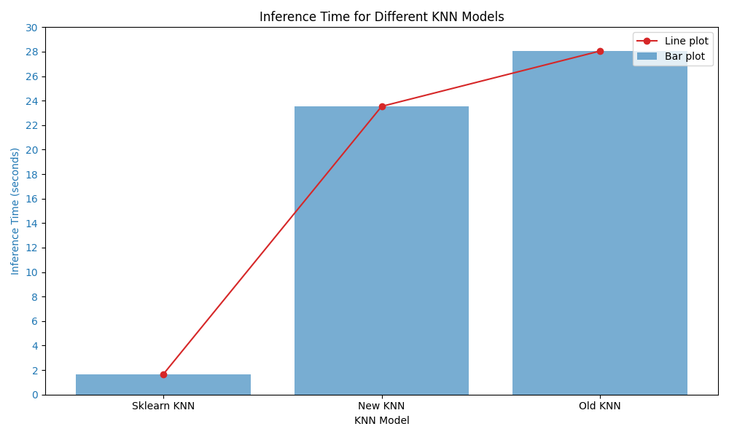

For 10000 data samples

task_2_5_3()

3. Plot the inference time vs train dataset size for initial KNN model, best KNN model, most optimized KNN model, and the default sklearn KNN model. Write down observations that you make based on this graph.

* dataset_sizes = ([100, 500, 1000, 5000, 10000, 50000, 114000])
* old_knn_times =([0.00275, 0.06090, 0.23844, 6.88793, 24.84275, 591.44909, 3029.85131])
* new_knn_times =([0.00234, 0.06524, 0.21555, 6.87011, 17.39268, 120.09435, 314.80442])
* sklearn_knn_times =([0.00225, 0.00583, 0.20349,  1.230361, 1.99732, 3.39953, 5.46194])

since there is large difference between values, used log/log scale

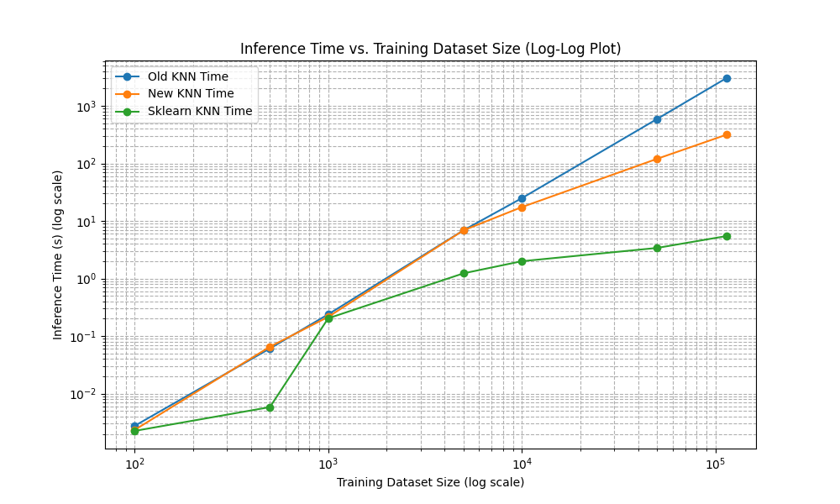

task_2_6()

2.6 Second Dataset:

There is another dataset given in data/external/spotify-2, which is already split into train.csv, validate.csv and test.csv. Using the best {k, distance metric} pair you got previously, apply KNN on this data and state your observations on the data and the performance of this data.

* WITH :k: 15, Distance Metric: Manhattan, Prediction Type: Weighted Sum

Result :

measures {'macro_precision': 0.1501911362929458, 'macro_recall': 0.1510026846327197, 'macro_f1': 0.14675549714933445, 'micro_precision': 0.15, 'micro_recall': 0.15, 'micro_f1': 0.15, 'accuracy': 0.9850877192982456}

Accuracy is same as obtained by sklearn with best ‘weighted sum’ and on full dataset

Linear Regression

Converges before max_epcoh if {np.all(np.abs(new_coefficients - self.coefficients) < self.tolerence=1e-6)

}

3.1 Simple Regression: Shuffle the data and make an 80:10:10 split into train, validation and test. Report metrics for all three sets

Task_3_1_0()

* Training Metrics:
* Variance (Train): 1.0862730512494836
* Standard Deviation (Train): 1.042244237810641
* Validation Metrics:
* Variance (Validation): 1.7663210794374133
* Standard Deviation (Validation): 1.3290301273625866
* Test Metrics:
* Variance (Test): 1.1421742596393099
* Standard Deviation (Test): 1.0687255305452892

3.1.1 Degree 1: Fit a line to the curve (y = β1x + β0). Report the MSE, standard deviation and variance metrics on train and test splits. Plot the training points with the fitted line

task_3_1_1()

Tried Learning Rate= [ 0.15, 0.2, 0.4,0.01, 0.05, 0.1]

Found Best learning rate: 0.4 with convergence at epoch 42 (best convergence)

At LR=0.4

Training Metrics:

Variance (Train): 1.0862730512494836

Standard Deviation (Train): 1.042244237810641

Test Metrics:

Variance (Validation): 1.1421742596393099

Standard Deviation (Validation): 1.0687255305452892

MSE test: 0.395541447387086

Line fitted on training data set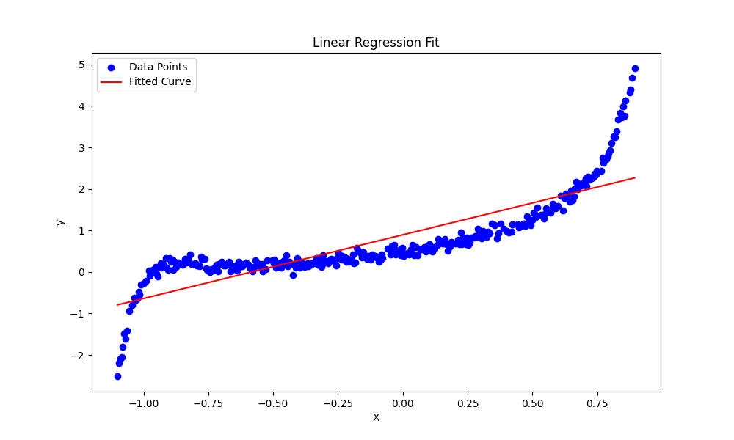

3.1.2 Degree > 1:Fit a polynomial to the curve (k degree polynomial). Make a class for regression that can take the value of k as a parameter. Test it with various values of k and report the MSE, standard deviation and variance metrics on train and test splits for all the values. Additionally, report the k that minimizes the error on the test set.

task_3_1_2()

tried on : k_lis = [ 1,2,3,4,5,6,7,11,20] , LR =0.1 (having >1 is not good)

variance ,Standard deviation on y_pred ,mse on (y_pred,y_true)

Plot made on X_train,Y_train

* k 1 has mse : 0.3955414029030607
* Variance: 0.7460429480989158
* Standard Deviation: 0.8637377773948038
* Converged at epoch: 166
* Train
* k 1 has mse : 0.3149730231382185
* Variance: 0.771284583633458
* Standard Deviation: 0.8782280931702526
* k 2 has mse : 0.20317969263986754
* Variance: 0.8270867024717325
* Standard Deviation: 0.9094430726943454
* Converged at epoch: 566
* Train
* k 2 has mse : 0.21549201166424767
* Variance: 0.8707656524653974
* Standard Deviation: 0.9331482478499316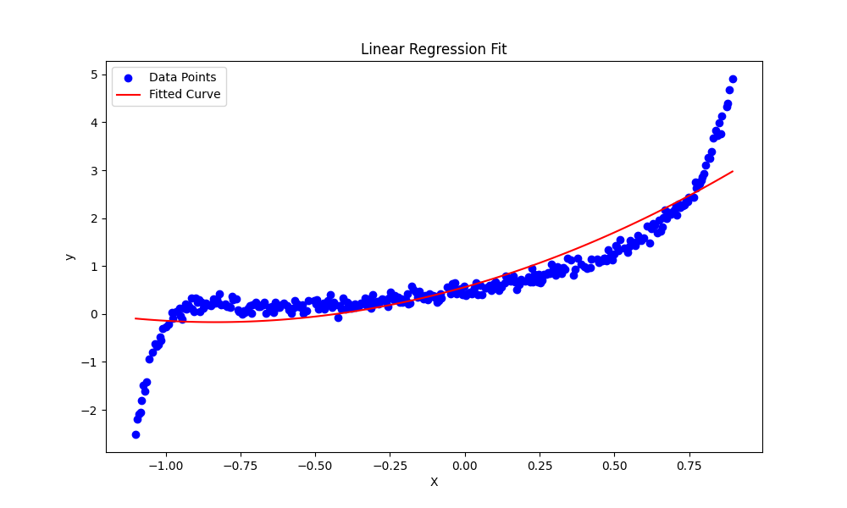
* k 3 has mse : 0.060824748056261826
* Variance: 1.0236171653396209
* Standard Deviation: 1.0117396727121166
* Converged at epoch: 2846
* k 4 has mse : 0.06311303501129592
* Variance: 1.0196011028895975
* Standard Deviation: 1.0097529910278045
* Converged at epoch: 9580
* k 5 has mse : 0.028743733799014286
* Variance: 1.0920579814814189
* Standard Deviation: 1.0450157804939688
* Converged at epoch: 10000
* Train
* k 5 has mse : 0.02548918675316326
* Variance: 1.0483414944892424
* Standard Deviation: 1.0238854889533509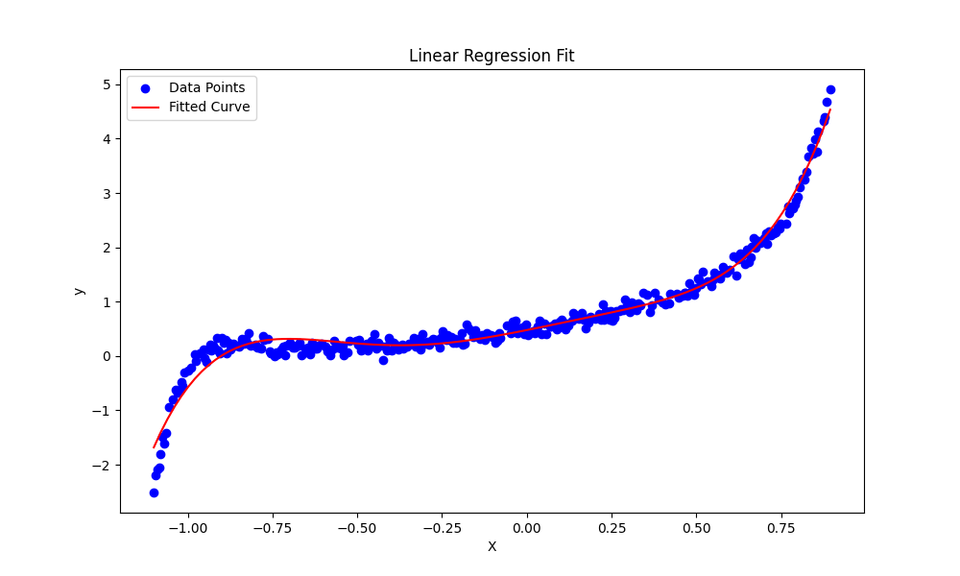
* k 6 has mse : 0.029537844201620665
* Variance: 1.075899855204575
* Standard Deviation: 1.037255925605911
* Converged at epoch: 10000
* k 7 has mse : 0.023211131805735443
* Variance: 1.098654630570873
* Standard Deviation: 1.0481672722284707
* Converged at epoch: 10000
* k 11 has mse : 0.019132435360465265
* Variance: 1.0705867312241004
* Standard Deviation: 1.0346916116525253
* Train
* k 11 has mse : 0.009315990301252153
* Variance: 1.0764663948275004
* Standard Deviation: 1.0375289850541527
* Converged at epoch: 10000 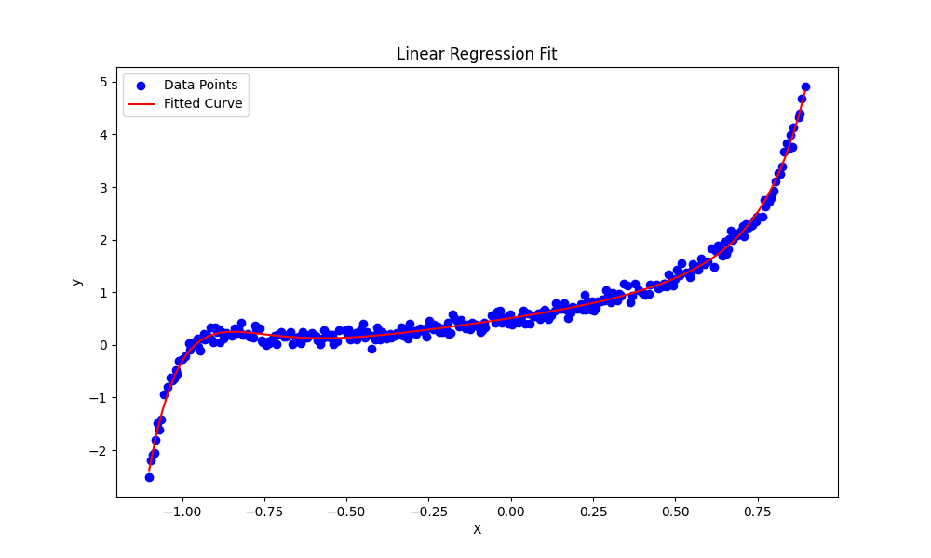
* k 20 has mse : 0.017839436488157945
* Variance: 1.063176519313167
* Standard Deviation: 1.031104514253122
* Converged at epoch: 10000
* Train
* k 20 has mse : 0.008738410686143219
* Variance: 1.0774580440492785
* Standard Deviation: 1.0380067649342553

Train :Best k that minimizes error 20 with mse 0.008738410686143219

Test :Best k that minimizes error 20 with mse 0.017839436488157945

• **Complexity vs. Performance:**

* As the degree kkk increases, the model becomes more complex, leading to lower test MSE but increasing the risk of overfitting, especially noticeable in higher degrees like k=11k = 11k=11 and k=20k = 20k=20.
* The variance and standard deviation do not vary drastically with kkk, but there is a slight increase, indicating that higher-degree models capture more variability in the data.

• **Optimal Degree Consideration:**

* For a balance between training accuracy and generalization, degrees around k=5k = 5k=5 to k=7k = 7k=7 might offer a good compromise. These models have reasonably low MSE and don't show extreme divergence between train and test performance.

• **Potential Overfitting:**

* At higher degrees (k=11k = 11k=11 and k=20k = 20k=20), the model shows very low training MSE but a comparatively higher test MSE, suggesting that while these models fit the training data exceptionally well, they may not generalize as effectively.

3.1.3 Animation: For each iteration, plot the original data along with the line you are fitting to it, as well as the MSE, standard deviation and variance

task_3_1_3()

for k in klis= [1,2,3,4,5,6,7,9]

Stored in assignments/1/figures/gif/convergence_k{k}.gif

K=1



K=2



K=3



K=5



K=7



K=9



3.2 Regularization

Function Parameters available:

PolynomialLinearRegression(degree=20, learning_rate=0.1, max_epochs=10000, tolerance=1e-6,regularization_type=None,lambda_=lamb)

Try fitting higher degree polynomials to the data (go up to 20). This will result in overfitting. Plot the data points and the resulting curves and report the MSE, standard deviation and variance for each. Use regularization to reduce the overfitting and plot the resulting curves again. Try both L1 and L2 regularization and compare the results

task_3_2(lamb)

Tried with LR=0.1,Degree=20, lambda=[0.01,0.1,0.5,1]

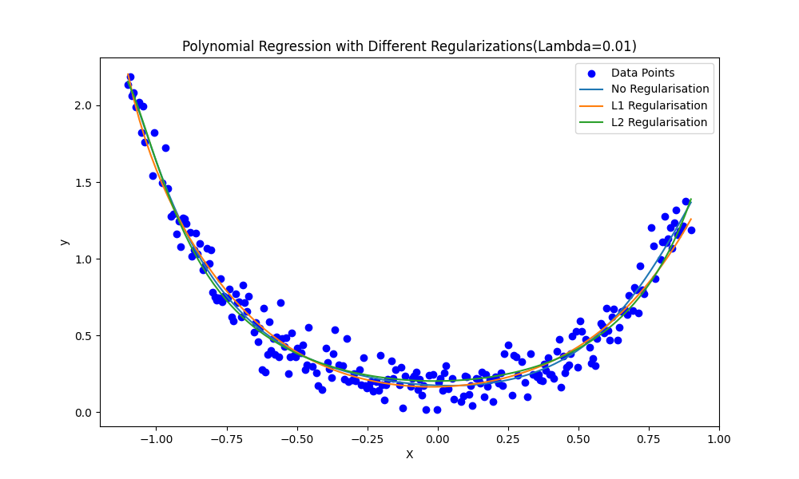

* No Regularisation
* Converged at epoch: 10000
* MSE test: 1.0286206948516765
* Variance: 0.19999915128393267
* Standard Deviation: 0.44721264660554116
* L1 Regularisation
* Converged at epoch: 10000
* MSE test: 1.0001649567232487
* Variance: 0.18294914031176862
* Standard Deviation: 0.4277255432070531
* L2 Regularisation
* Converged at epoch: 3539
* MSE test: 1.0201712145619457
* Variance: 0.18420292067385757
* Standard Deviation: 0.4291886772433047

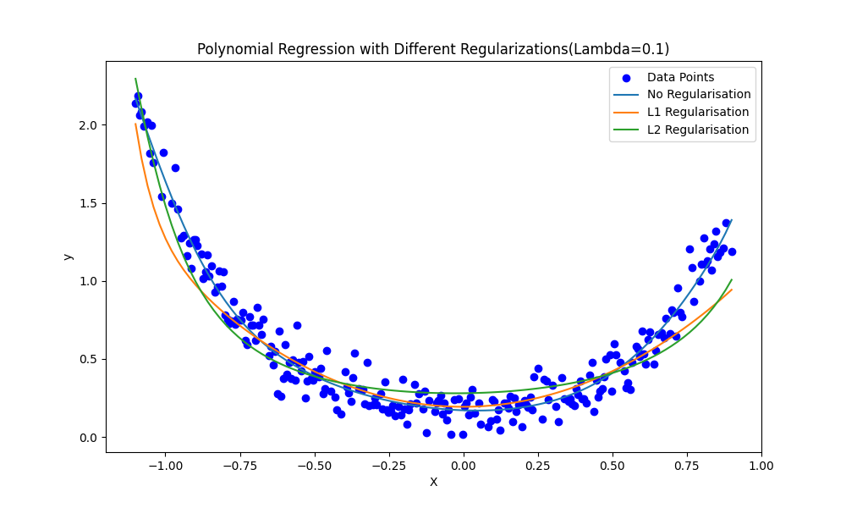

No Regularisation

Converged at epoch: 10000

MSE test: 1.0286206948516765

Variance: 0.19999915128393267

Standard Deviation: 0.44721264660554116

L1 Regularisation

Converged at epoch: 10000

MSE test: 1.0001649567232487

Variance: 0.18294914031176862

Standard Deviation: 0.4277255432070531

L2 Regularisation

Converged at epoch: 3539

MSE test: 1.0201712145619457

Variance: 0.18420292067385757

Standard Deviation: 0.4291886772433047

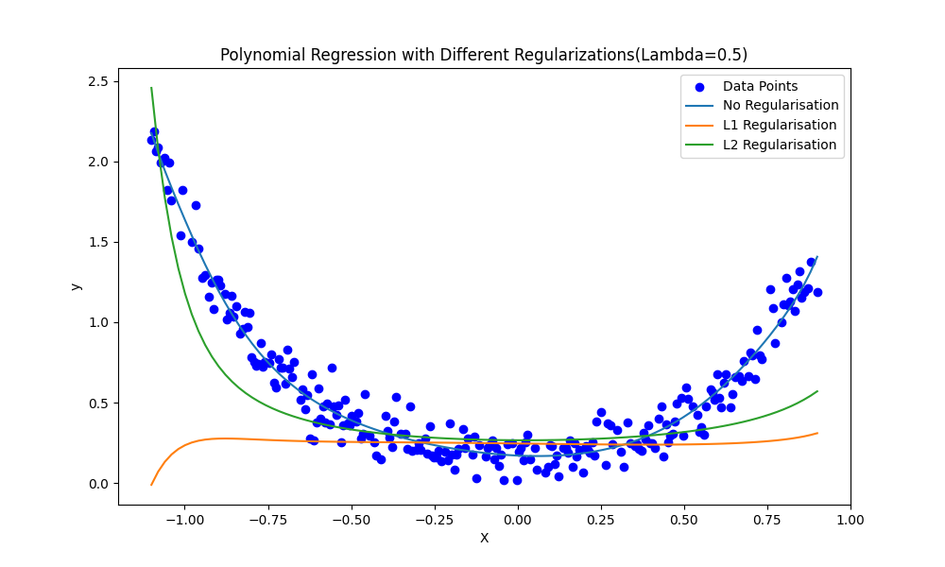

No Regularisation

Converged at epoch: 10000

MSE test: 1.0286206948516765

Variance: 0.19999915128393267

Standard Deviation: 0.44721264660554116

L1 Regularisation

Converged at epoch: 10000

MSE test: 1.0001649567232487

Variance: 0.18294914031176862

Standard Deviation: 0.4277255432070531

L2 Regularisation

Converged at epoch: 3539

MSE test: 1.0201712145619457

Variance: 0.18420292067385757

Standard Deviation: 0.4291886772433047

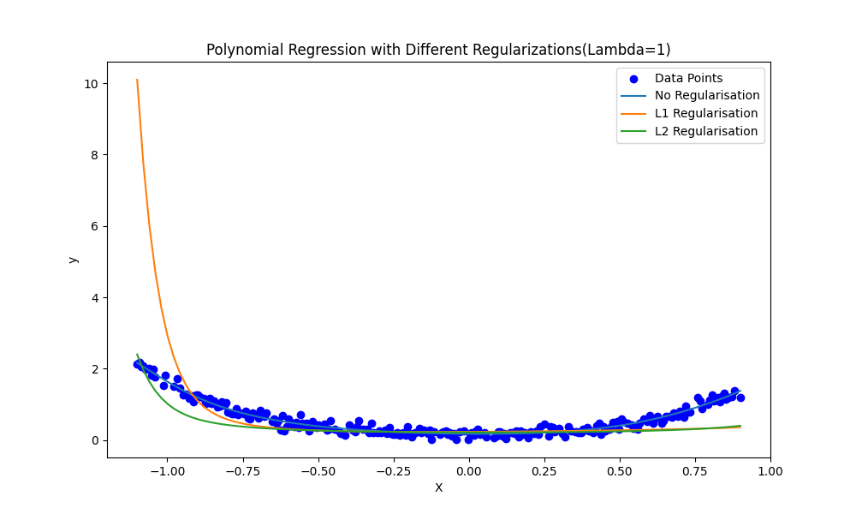

No Regularisation

Converged at epoch: 10000

MSE test: 1.0286206948516765

Variance: 0.19999915128393267

Standard Deviation: 0.44721264660554116

L1 Regularisation

Converged at epoch: 10000

MSE test: 1.0001649567232487

Variance: 0.18294914031176862

Standard Deviation: 0.4277255432070531

L2 Regularisation

Converged at epoch: 3539

MSE test: 1.0201712145619457

Variance: 0.18420292067385757

Standard Deviation: 0.4291886772433047

Bonus : task_3_2animation()

For Degree =10 ,LR =0.2 , lambda=0.4 ,regularization_type=[none,L1,L2]

Note :Regarding all animation MSE,Variance and Standard devation of 1st 150 epoch is shown, Mse is shown epoch form 1 to converging epoch (sampled 150 evenly)

1. NONE



1. L1



1. L2



///////////////

LR=0.01 ,Degree=20

None



L1 

L2 

1. **No Regularization:**
   * Regardless of the lambda value (0.01, 0.1, 0.5, or 1), the model without regularization consistently converges at 10,000 epochs.
   * The MSE test value remains the same at 1.0286206948516765 across all lambda values.
   * The variance and standard deviation also remain constant at 0.19999915128393267 and 0.44721264660554116, respectively.
   * This suggests that without regularization, the model performance is not influenced by the lambda value.
2. **L1 Regularization:**
   * For all lambda values (0.01, 0.1, 0.5, 1), the model with L1 regularization also converges at 10,000 epochs.
   * The MSE test value is lower (1.0001649567232487) compared to the model with no regularization.
   * The consistent performance across different lambda values indicates that L1 regularization has a stabilizing effect on the model but does not significantly alter the convergence behaviour or error metrics.
3. **L2 Regularization:**
   * Unlike the other configurations, the model with L2 regularization converges much earlier, at 3539 epochs for all lambda values.
   * The MSE test value is slightly better than the no-regularization case but not as good as L1 regularization.
   * The variance and standard deviation are somewhat reduced compared to no regularization but are slightly higher than with L1 regularization.
   * The early convergence with L2 regularization suggests that it helps in faster optimization of the model, possibly leading to a quicker stabilization of weights.

**Key Insights:**

* **Effect of Regularization:**
  + Both L1 and L2 regularization improve the model's performance compared to no regularization, as evidenced by the lower MSE values.
  + L1 regularization appears to be slightly more effective in reducing MSE, variance, and standard deviation compared to L2.
  + L2 regularization, however, leads to faster convergence, which might be desirable in cases where computational efficiency is critical.
* **Effect of Lambda:**
  + The lambda value does not seem to have a significant impact on the final performance metrics (MSE, variance, standard deviation) within the tested range.
  + This might indicate that the regularization effect is strong enough that small changes in lambda do not significantly alter the model's behavior.